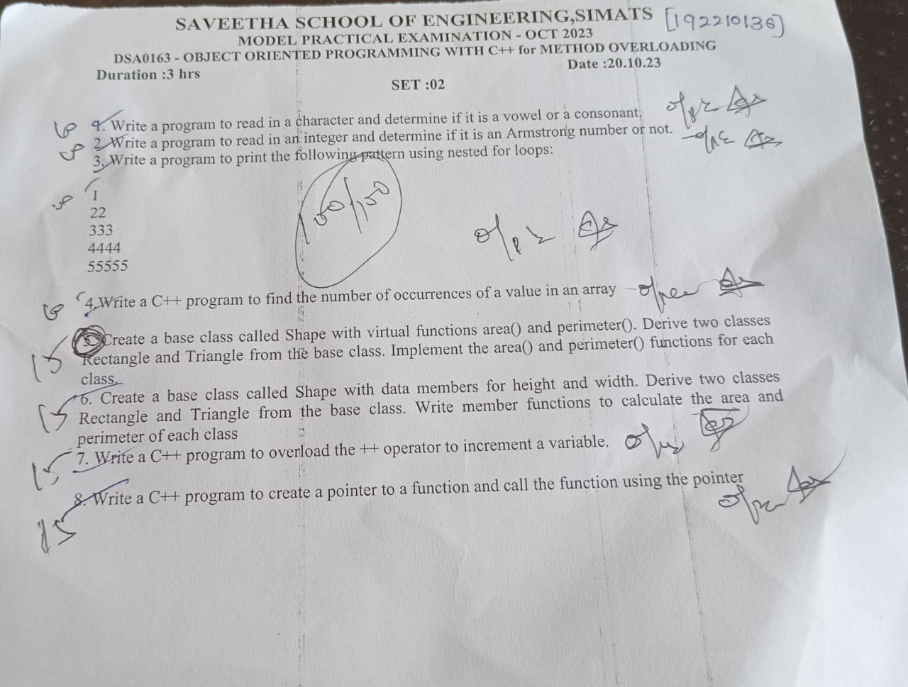

1)

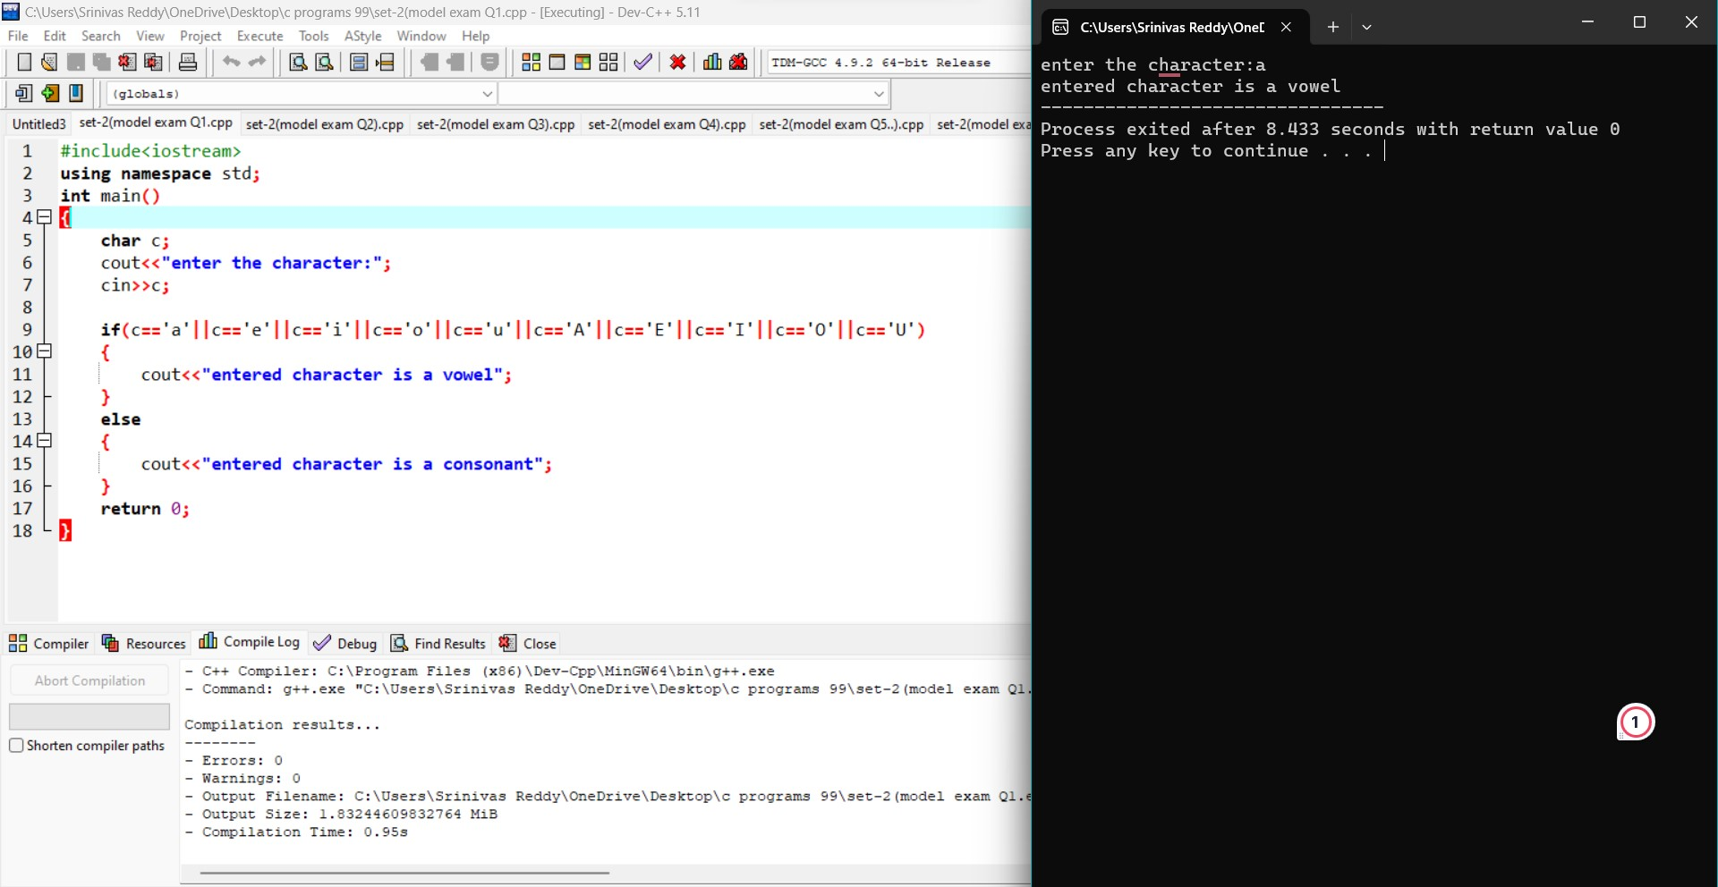

2)

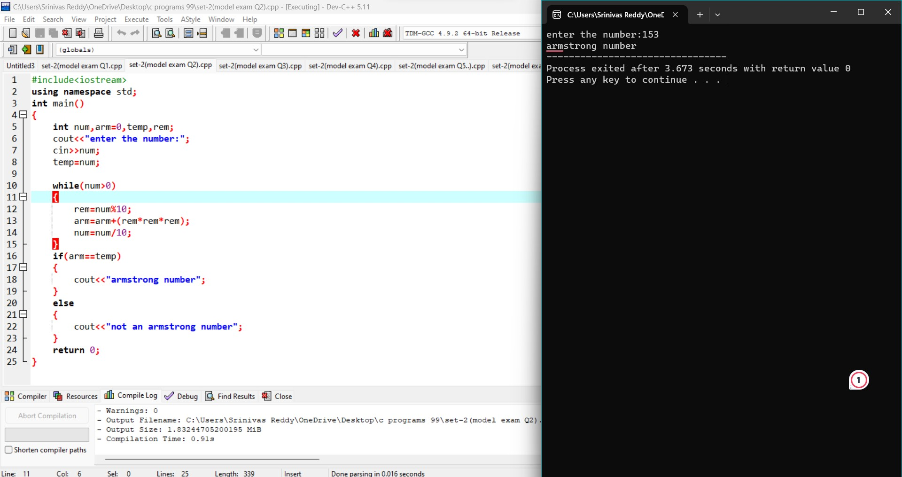

3)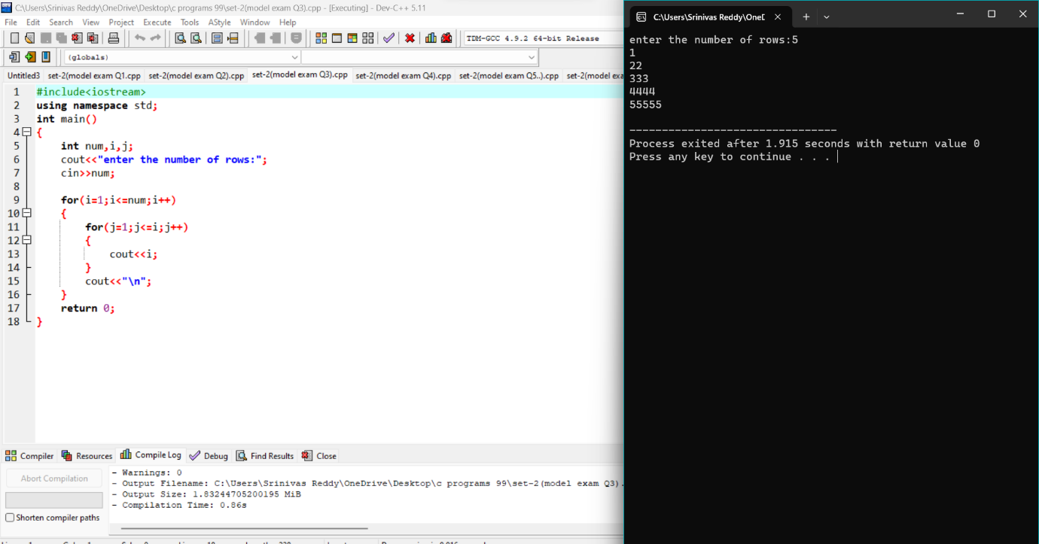

4)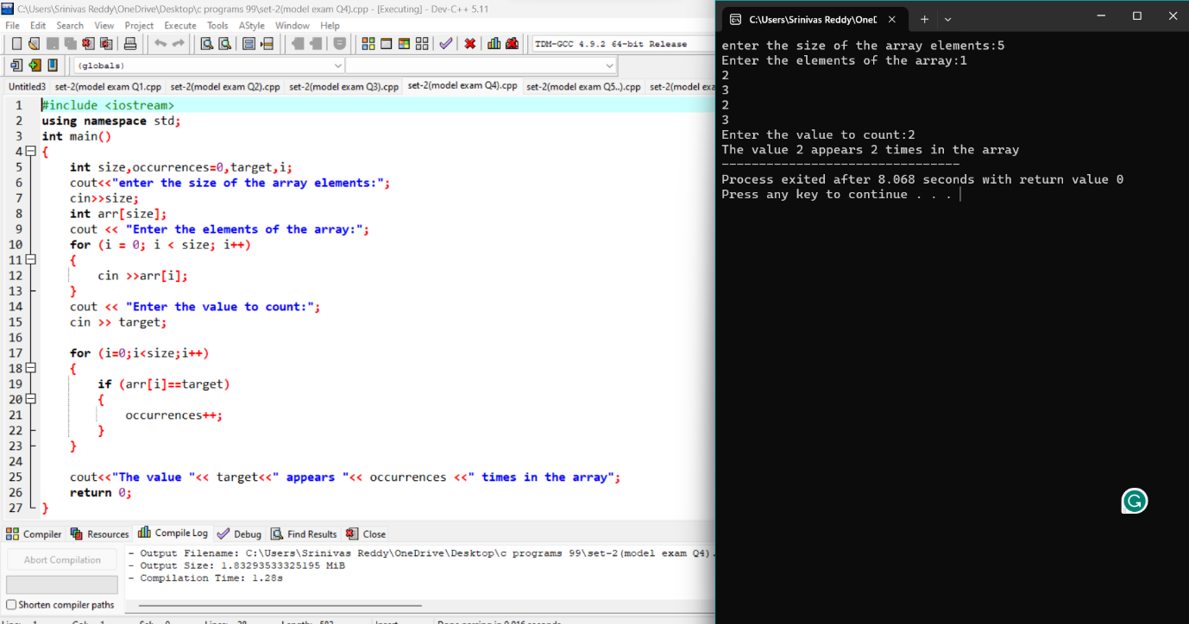

3)2)

5) #include <iostream>

using namespace std;

class Shape

{

public:

virtual double area() {

return 0.0;

}

virtual double perimeter() {

return 0.0;

}

};

class Rectangle : public Shape

{

private:

double length;

double width;

public:

Rectangle(double l, double w) : length(l), width(w){}

double area()

{

return length \* width;

}

double perimeter()

{

return 2 \* (length + width);

}

};

class Triangle : public Shape {

private:

double side1;

double side2;

double side3;

public:

Triangle(double s1, double s2, double s3) : side1(s1), side2(s2), side3(s3) {}

double area()

{

double s = (side1 + side2 + side3) / 2;

return (s \* (s - side1) \* (s - side2) \* (s - side3));

}

double perimeter()

{

return side1 + side2 + side3;

}

};

int main()

{

Shape\* shape1 =new Rectangle(5.0, 4.0);

Shape\* shape2 =new Triangle(3.0, 4.0, 5.0);

cout << "Rectangle Area: " << shape1->area() << "\n";

cout << "Rectangle Perimeter: " << shape1->perimeter() << "\n";

cout << "Triangle Area: " << shape2->area() << "\n";

cout << "Triangle Perimeter: " << shape2->perimeter() << "\n";

delete shape1

delete shape2;

return 0;

}

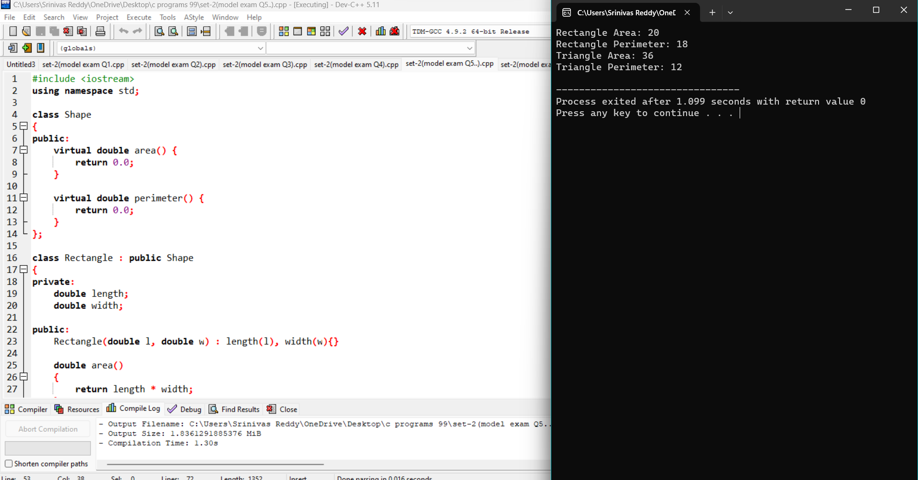

6) #include <iostream>

using namespace std;

class Shape

{

public:

double height,width;

void get()

{

cout<<"Enter height: ";

cin>>height;

cout<<"Enter width: ";

cin>>width;

}

void set()

{

cout<<"Height:"<<height<<"\n";

cout<<"Width:"<<width <<"\n";

}

double calculateArea()

{

return 0.0;

}

double calculatePerimeter()

{

return 0.0;

}

};

class Rectangle:public Shape

{

public:

double calculateArea()

{

return height\*width;

}

double calculatePerimeter()

{

return 2\*(height+width);

}

};

class Triangle:public Shape

{

public:

double calculateArea()

{

return 0.5\*height\*width;

}

double calculatePerimeter()

{

double hypotenuse=2\*(height\*height+width\*width);

return height+width+hypotenuse;

}

};

int main()

{

Shape shape;

shape.get();

shape.set();

Rectangle rectangle;

rectangle.get();

cout<<"rectangle area:"<<rectangle.calculateArea()<<"\n";

cout<<"rectangle perimeter:"<<rectangle.calculatePerimeter()<<"\n";

Triangle triangle;

triangle.get();

cout<<"triangle area:"<<triangle.calculateArea()<<"\n";

cout<<"triangle perimeter:"<<triangle.calculatePerimeter()<<"\n";

}

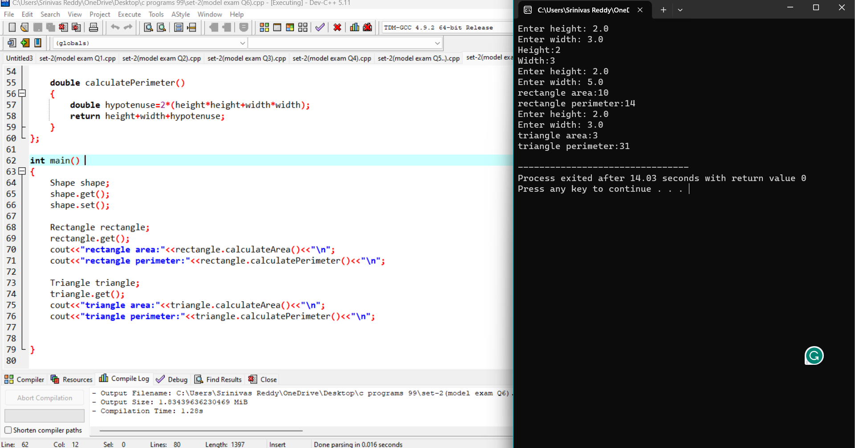

7) 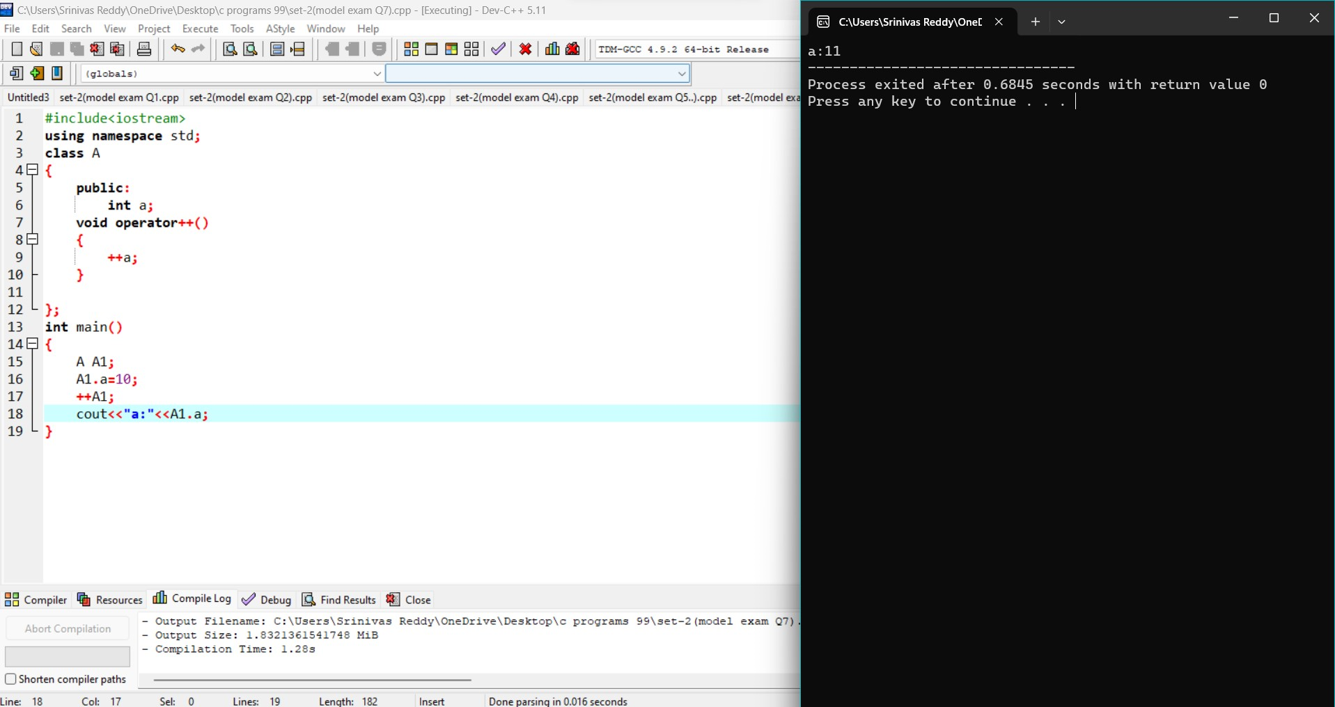

8) 